Dated 07.05.2024.

**ElasticBeanstalk Lab**

Make sure you have one key-pair in this region, if not create ONE.

Step 1 >>> Create a IAM Role for Elastic Beanstalk to access the services >>> EC2 ( root User )

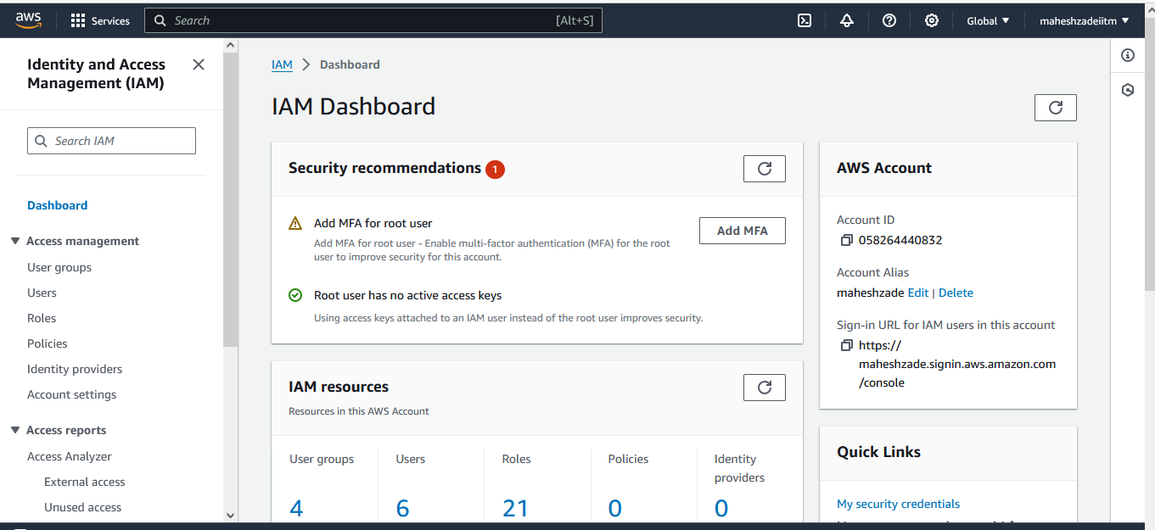

Roles >>> Create a Role >>> AWS service

>>> Use case >>>> EC2

>>> Next

Policy >>>> AWSElasticBeanstalkWebTier

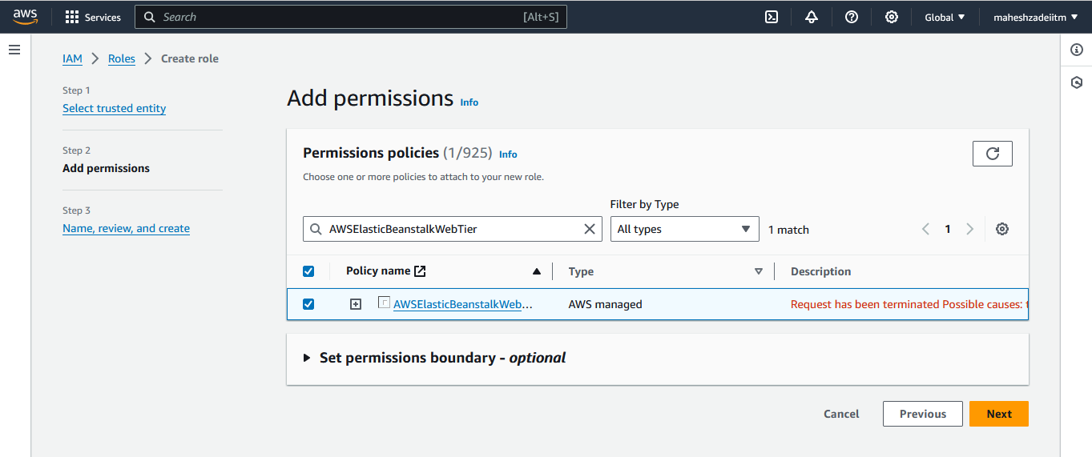

Next

Role name >>> AWSElasticBeanstalkRole1

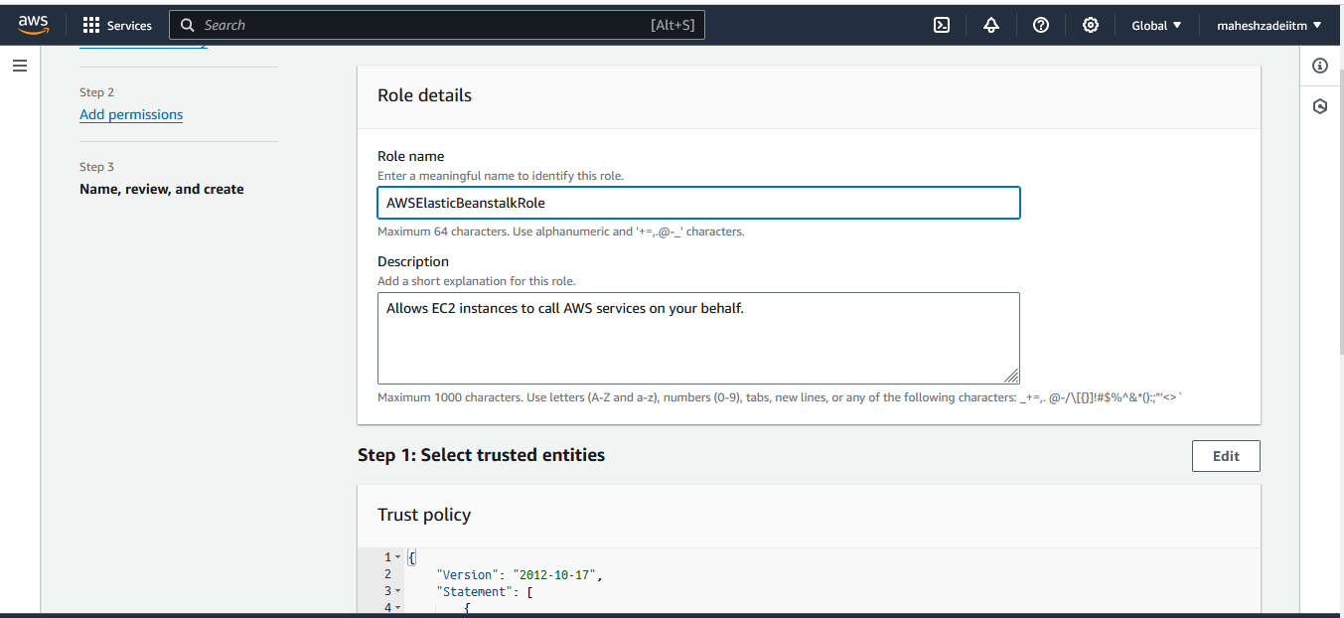

Create a Role

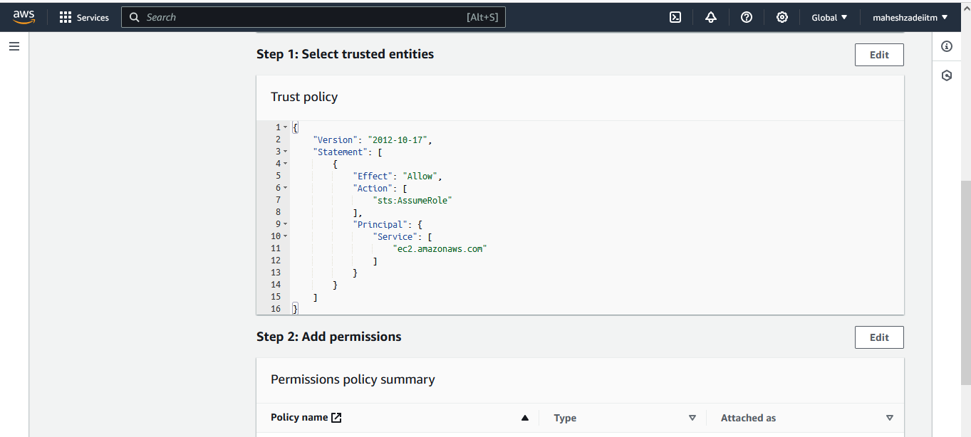

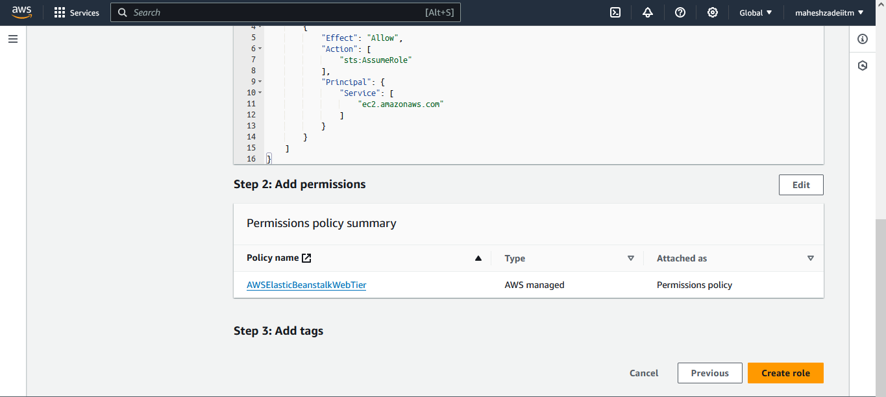

Step 2 >>>>> Go to Elastic Beanstalk >>> Create a Application

Environment tier >>>> Web server environment

Application information >>>> myabcapplication

Environment name >>> will be automatically creating

Domain >>> Leave it blank

Platform type >>>>> Managed platform

Platform >>>>> PHP

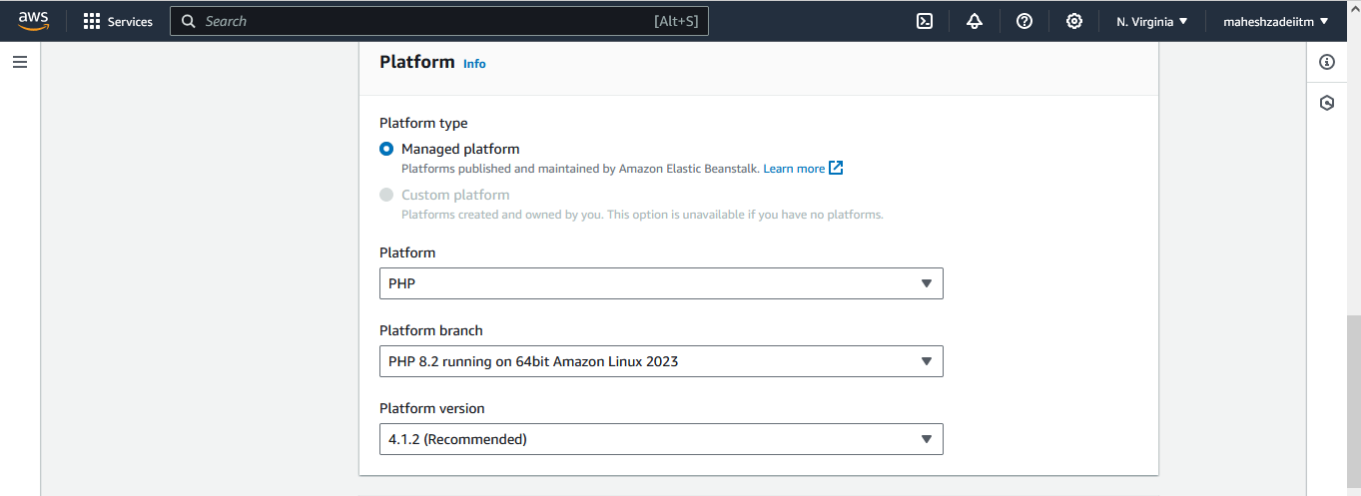

Application code >>> Sample application

Presets >>> Configuration presets >>> Single instance (free tier eligible)

Next

Configure service access

Service role >>>> Use an existing service role >>> Choose your IAM role that you have created above

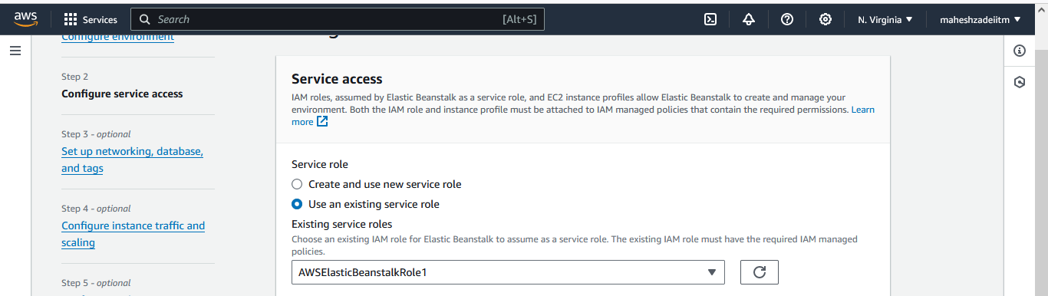

EC2 key pair >>> Choose your key-pair

EC2 instance profile >>> Choose your IAM role that you have created above

Next

Set up networking, database, and tags

VPC >>> Choose your VPC either default or custom

Instance settings >>> Public IP address >>>> Activated

Instance subnets >>> Choose your Public Subnet

No Database for this scenario >>> leave all the options and Next

Leave all the options till EC2 security groups

EC2 security groups >> choose Default SG

Leave all the options till Instance types

Instance types >>> remove those default instance types and choose t2.micro

Leave all the options >>> Next

Configure updates, monitoring, and logging

Health reporting >> Basic

Managed platform updates >>> Uncheck

Leave all the options

Next

Review and Submit

Now you can monitor what is happening at the Events

Monitor EC2 Instance creating

Environment Successfully launched

Now Check the Events

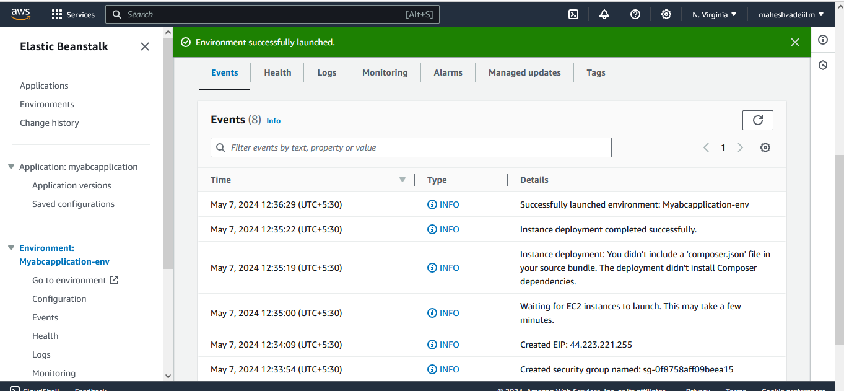

Now Check the Doman URL , copy and paste in browser

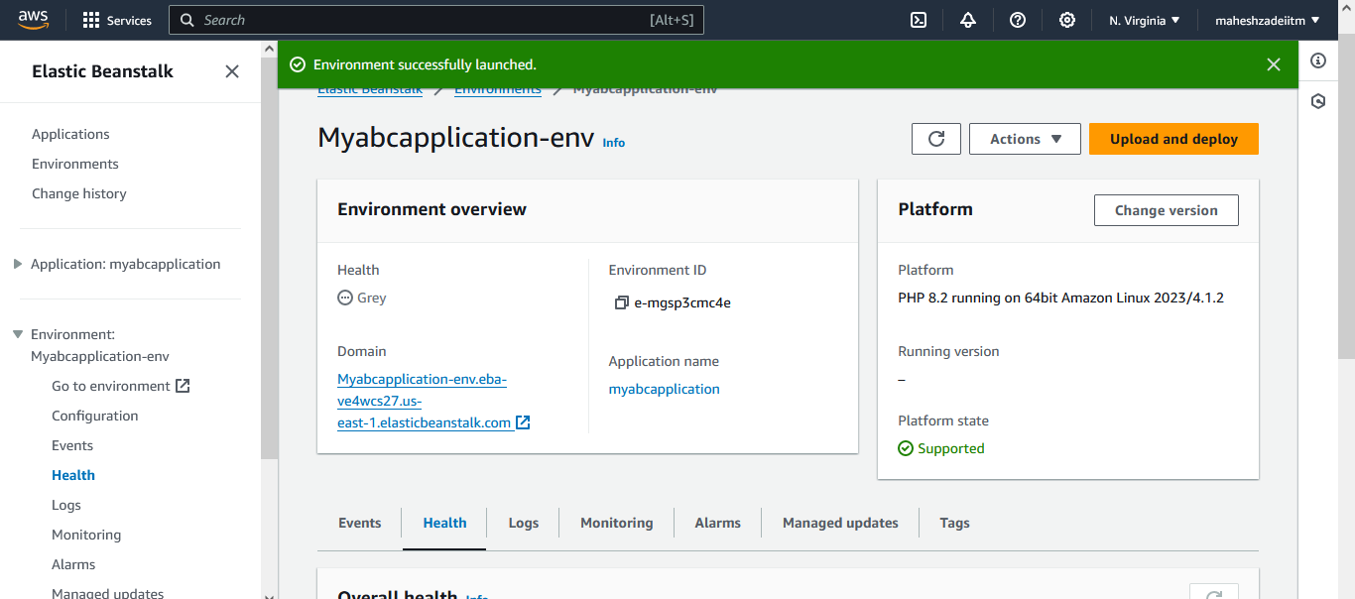

URL :

<http://myabcapplication-env.eba-ve4wcs27.us-east-1.elasticbeanstalk.com/>

PHP application launched Succesfully

Thanks

Pls check and confirm .